LMYC
LIFE MANAGEMENT YOGA CENTRE
HOW TO BOOK A CLASS

Table of Contents

NEW STUDENT 3

ALREADY REGISTERED STUDENT 7

NEW STUDENT
Open the LMYC site www.yoga.org.hk . You will see the following screen: Click on the Button called ‘Book a Class’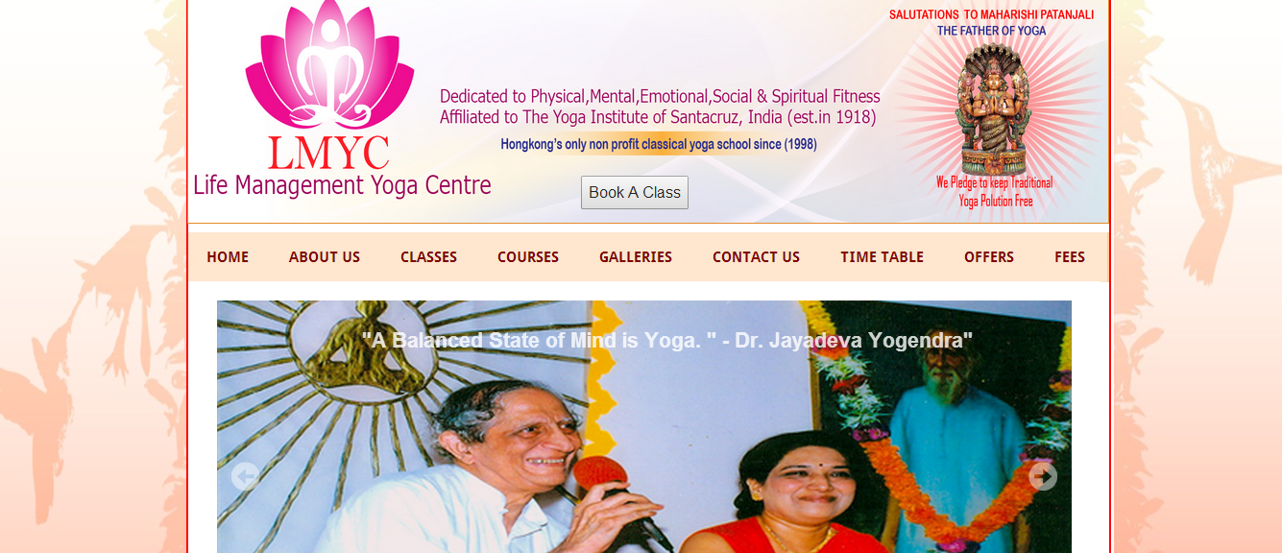-

- The following screen would be seen.
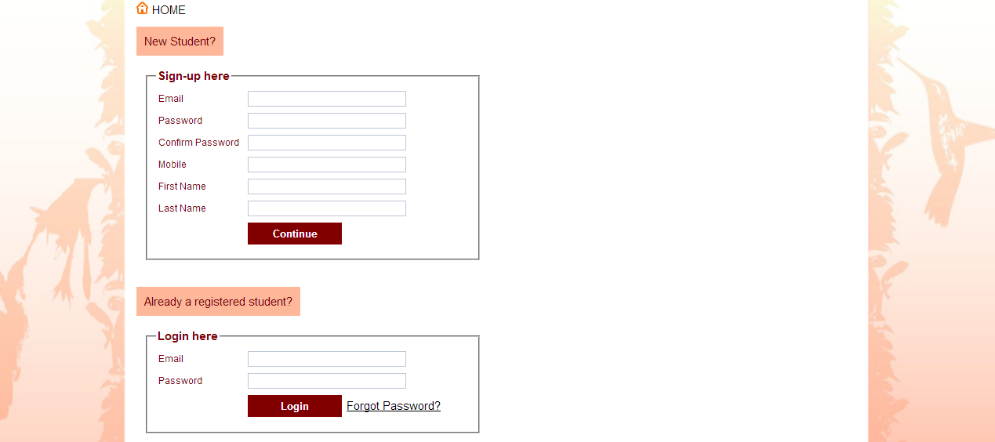
As you are a new student One Time Registration needs to be done by filling the Box under New Student. After filling all the information click on Continue. (Note:- You need to remember the E-mail ID as you will always login to this system using this E-mail ID and the password set by you).
The following screen would be seen:-
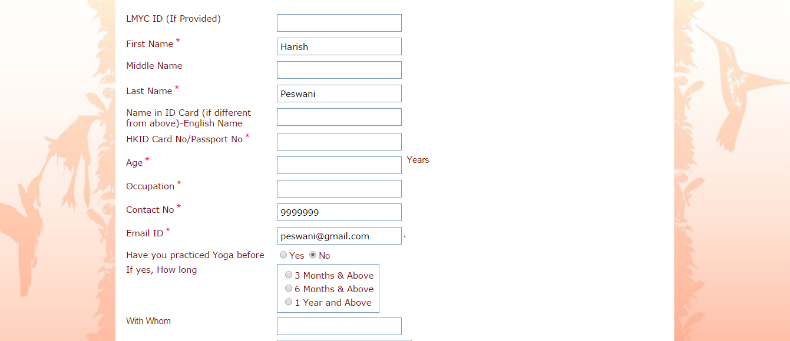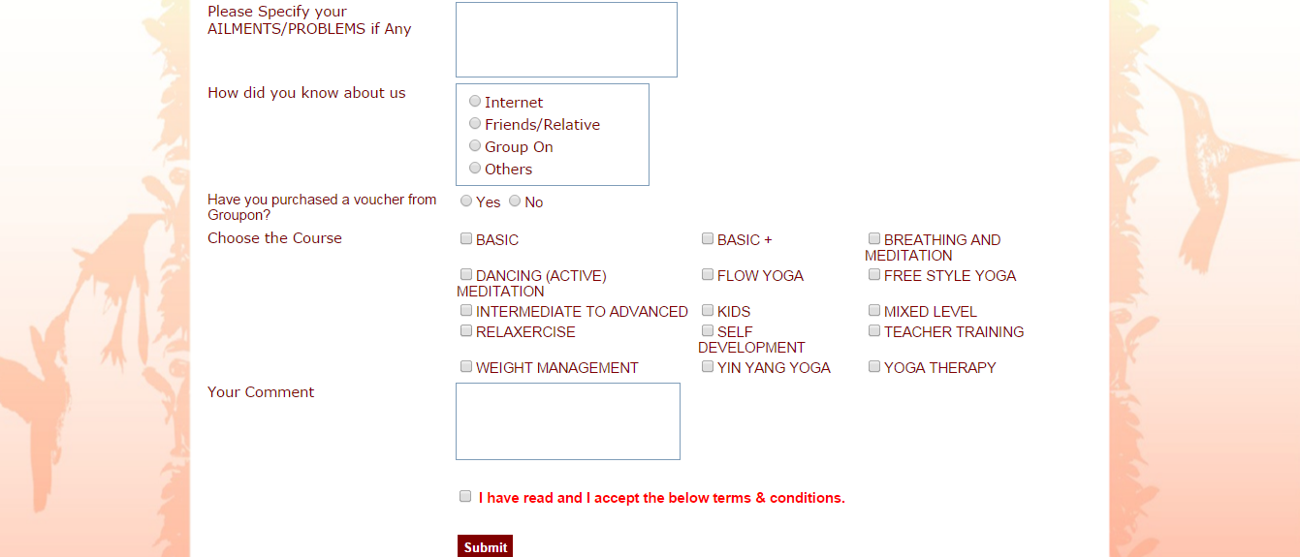
Type in the needful details on this form. Please note that HongKongID Card No/Passport No, Age and Occupation are Mandatory Fields.
IMPORTANT: - As you are from GroupOn, please select Yes to the question which says – Have you purchased a voucher from GroupOn?
Fill in all the relevant details and click on Submit.
The following screen would be seen. Now fill in the Security Code and the Voucher Code on your GroupOn Voucher in the boxes below. Also select the number of sessions purchased (6/12) and click on Proceed.
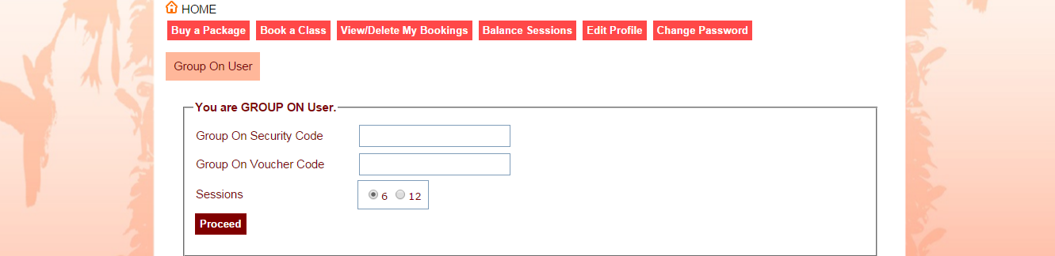
Accordingly number of sessions would be allotted to you and a promo code would be assigned to you. Note down this promo code as this would be your LMYC ID for all your future.
Congratulations – You have registered yourself and now you are all ready for Booking a Class.
To Book a Class on the top Click on the Button Book A Class. You will see the following screen. Choose the type of class by clicking on this dropdown, and select the day you want to book for by clicking on this Drop Down Arrow or you can see timetable for all days by just choosing (All Days) and clicking on Search.
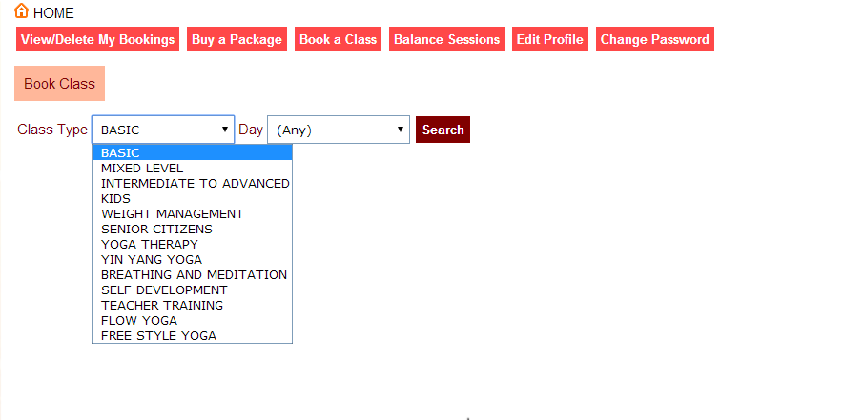
For e.g. if you choose Basic and choose (All Days) you will see a screen as shown below. You can Book a Class by clicking on the Book Button

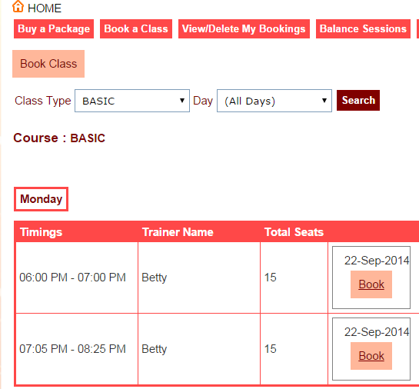

YOU ARE ALL SET NOW TO ATTEND YOUR FIRST SESSION AT LMYC. NO OTHER CONFIRMATION IS REQUIRED.

- PLEASE REMEMBER TO CARRY THE PRINT OUT OF YOUR GROUPON VOUCHER WHEN YOU REACH LMYC.
- PLEASE REACH LMYC 5 MINUTES BEFORE YOUR BATCH TIME.
- IF YOU REACH LATE BY 10 MINUTES YOU WOULD NOT BE PERMITTED TO ENTER THE CLASS.

ALREADY REGISTERED STUDENT
Open the LMYC site www.yoga.org.hk . You will see the following screen: - Click on the Button called ‘Book a Class’

- The following screen would be seen.

Type in your Email id and the password that you created during registration in the boxes above and Click on Login.
To Book a Class on the top Click on the Button Book A Class. You will see the following screen. Choose the type of class by clicking on this dropdown, and select the day you want to book for by clicking on this Drop Down Arrow or you can see timetable for all days by just choosing (All Days) and clicking on Search.
For eg if you choose Basic and choose (All Days ) you will see a screen as shown below. You can Book a Class by clicking on the Book Button

YOU ARE ALL SET NOW TO ATTEND YOUR SESSION AT LMYC. NO OTHER CONFIRMATION IS REQUIRED.

- PLEASE REACH LMYC 5 MINUTES BEFORE YOUR BATCH TIME.
- IF YOU REACH LATE BY 10 MINUTES YOU WOULD NOT BE PERMITTED TO ENTER THE CLASS.

